 Maiden Bradley with Yarnfield Parish Council

9 Beech Grove, Warminster, Wiltshire, BA12 0AB Tel: 01985 213436
Chairman: Councillor Angus Neish Clerk Mrs Sarah Jeffries MILCM

All Parish Council Meetings are open to the Public and Press

Tuesday 10th July 2012

To All Members of Maiden Bradley with Yarnfield Parish Council

Dear Councillor,

You are summoned to a meeting of Maiden Bradley with Yarnfield Parish Council, at Maiden Bradley Village Hall on Tuesday 10th July 2012 at 7.30pm. The meeting will consider the items set out below.
Before the meeting there will be a public session to enable the people of Maiden Bradley to ask questions of, and make comments, regarding the Parish Council. Questions not answered at this meeting will be answered in writing to the person asking the question, or may appear as an agenda item for the next meeting. Members of the public are asked to restrict their comments, and/or questions to three minutes.
Sarah Jeffries MILCM 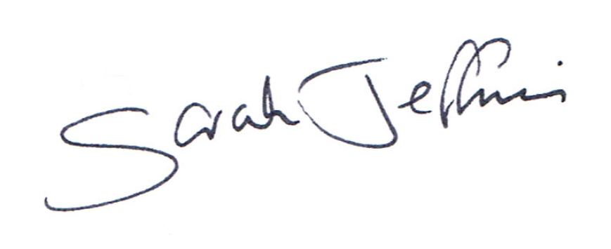
Parish Clerk
----------------------------------------------------------------------------------------------------------------
7.30pm Public Question Time
This section (at the Chairman’s discretion may last up to 15 minutes) is not part of the formal meeting of the Council and minutes will not be produced. Public Bodies (admissions to meetings) Act 1960 s 1 extended by the LG Act 972 s 100.

Report from Unitary Councillor

Report from Rural Police Department

Agenda

1. Acceptance of apologies for absence
Schedule 12 of the Local Government Act 1972 requires a record to be kept of the members present and that this record form part of the minutes of the meeting. Members who cannot attend a meeting should tender apologies to the Parish Clerk as it is usual for the grounds upon which apologies are tendered also to be recorded. Under Section 85(1) of the Local Government Act1972, members present must decide whether the reason(s) for a member's absence are accepted.

2. Chairman’s announcements

3. To receive declarations of interests Local Authorities
To receive any disclosure(s) of interest by a Councillor or as an Officer in matters to be considered at this meeting, in accordance with the Local Authorities Code of Conduct order 2007 SI no.1159. (NB this does not preclude any later declarations).
A member must, within 28 days of becoming aware of any changes to the Interests specified in the register of members Interests, provide written notification to the Monitoring Officer.
A member must within 28 days of receiving any gift or hospitality over the value of £25.00, whilst in their official capacity under the code, provides written notification to the monitoring officer of the existence and nature of that gift or hospitality.

4. Exclusion of the Press and Public Standing Order #1c

5. To receive and sign the minutes of the Full Council meeting held on 12th June 2012 (Previously circulated) LGA 1972 Sch 12 para 41(1)

6. Co-option
Council is asked to discuss the candidates LGA 1972 s16A

7. Localism Act 2011 – Code of Conduct
Council is asked to hear an update from the Clerk following her attendance at the Salisbury Guildhall meeting & SLCC meeting with Wiltshire Council Solicitor Ian Gibbons. Council is asked to discuss and resolve which Code of Conduct it wishes to approve, the Wiltshire Council version or NALC version.

Register of Interests
Councillors are asked to hear a letter from Nina Wilton Head of Governance and Deputy Monitoring Officer Wiltshire Council.

8. Parish Documentation Media Policy
Council is asked to note that the Clerk has found a large amount of legislation for Social Media and is awaiting confirmation from an adviser so will bring the draft to the September meeting.

9. Parish Steward
Council is asked to discuss and compile a list of works required, ready for the next Parish Stewards visit of any items seen or reported to them by parishioners.

10. 1 Tonne Salt Bag Scheme
Council is asked to discuss whether it wishes to partake in the scheme whereby a farmer or parishioners holds the 1 tonne bag of salt in a dry storage area with easy access and is able to manage the distribution of the salt that they participate as a Snow Warden. The Parish Council is invited to develop a snow warden scheme and to develop a parish weather response plan with Wiltshire Council. Council is asked following its discussions, to inform the Clerk of its decision.

11. Community Emergency Volunteer Plan
Councillors are asked by the Clerk to update her with any further contacts they have gained for the Initial Response Plan the Clerk had supplied.

12. Village Hall
Council is asked to discuss the information reported.

13. Grant Applications LGA 1972 s137
Council is asked to discuss any applications received by the Clerk.

14. Clerk’s Report

Knapp Fencing
Council is asked to hear an update on the Knapp fencing

Recreational Area
The Frome Football Team have asked if they could continue to use the recreational field for next Season, Council is asked to confirm if it is happy for the arrangement to continue.

15. Mendip District Council
Council is asked to note that there has been an appeal put into the Secretary of State regarding Land at Bunns Lane West Woodlands Nr Frome Proposal Erection of Poultry Buildings etc.
The appeal reference is APP/Q3305/ A/12/2176896/NWF the end date for comment is the 19th July 2012. Any comments already made will be forwarded to the Inspector should Council wish to modify or withdraw its earlier comments please could it inform the Clerk so she can reply within the deadline.

16. Parish Council Logo
Council is asked to confirm the design it wishes the Clerk to use for the Parish Council documentation.

17. Meetings for Councillors to consider attending
At the time of producing the Agenda the Clerk had no meetings to report.

18. VAT Return
Council is asked to note that the Clerk has actioned the VAT claim for £ 447.53 for 13.03.12 to the 12.06.12

19. Approval and signing off Parish Accounts June 2012

20. Payments
To review and approve the items of expenditure listed below: LGA 1972 s150 (5)

Invoices
Wages LGA 1972 s111 £330.46
Travelling LGA 1972 s111 £ 7.74
Heat & Light etc. LGA (Financial Provisions) act 1963 s5 £ 6.93
Postage £ 13.10
K. M. Dike Nurseries July Grounds Maintenance £252.73

Receipts
Longbridge Deverill & Crockerton IT contribution £ 15.00
Longbridge Deverill & Crockerton Equipment contribution £198.96
Horningsham Equipment Contribution £198.96

Council is asked to note that the Clerk has moved £1000.00 from account number 07052153 to 00108234.

21. Planning
S/2012/902/FUL 18 Church Street Maiden Bradley
Full Planning Single Storey Rear Extension
Council is asked to discuss the above application and inform the Clerk of its decision.

22. Parish Clerks Delegated Powers
The Clerk will give Council details of any matters dealt with under her delegated powers, since the last meeting of Council. LGA 1972 s101

23. Correspondence
Council is asked to note the correspondence received below;
Julie Girling MEP South West of England- poster & letter of introduction
Three Rivers Partnership
Village Hall Project

24. Notice of items to be taken into consideration at the next meeting.
Councillors are asked to highlight any items to the Clerk.

25. Items for Parish Newsletter & Notice Boards
Councillors are asked to inform the Clerk of any other items it wishes the Clerk to highlight in the Parish News.

26. Items for the next Agenda
½ year budget review
Parish Footpath Standard Review (Deferred till September)

27. Date of the next meeting
The Council is asked to note that the 11th September 2012 is the date of the next meeting. All are welcome to attend.
Council are asked to note that in the exercise of their functions they must take note of the following: Equal opportunities (race, gender, sexual orientation, marital status and any disability); Crime and Disorder, Health and Safety and Human Rights. Any person who may find difficulty in access to the meeting through disability is asked to advise the Clerk (07540 611906) or 01985 213436 email (maidenbradleypc@o2.co.uk) at least 24 hours before the meeting so that every effort may be made to provide access.

